Project Performance Test

Date | 15 July 2026
Team ID | Team 1
Project Name | UNESCO World Heritage Site Analysis Using Tableau
Maximum Marks

S.No | Parameter | Screenshot / Values
1 | Data Rendered | Successfully rendered UNESCO World Heritage Sites dataset containing heritage site details such as Site Name, Country, Category (Cultural/Natural/Mixed), Region, Year of Inscription, Latitude, and Longitude. Fig-1.
2 | Data Preprocessing | Removed duplicate records, handled missing values, corrected data types, and formatted fields before importing into Tableau. Fig-2.
3 | Utilization of Filters | Implemented interactive filters for Country, Category, Region, and Year of Inscription. Fig-3.
4 | Calculation Fields Used | Total Heritage Sites, Count of Cultural Sites, Count of Natural Sites, Count of Sites Inscribed, Count of Name, Date inscribed, Count of Danger, Sum of Area Hectors.
5 | Dashboard Design | No. of Visualizations/Graphs: 8, World Map, Bar Chart, Pie Chart, Line Chart, KPI Cards, Tree Map, etc. Fig-4.
6 | Story Design | No. of Story Points: 2. From 2 dashboards. UNESCO World Heritage Sites Overview and UNESCO Danger Sites Overview. Fig-5.

Performance Testing Screenshots
Figure 1: Data Source Loaded
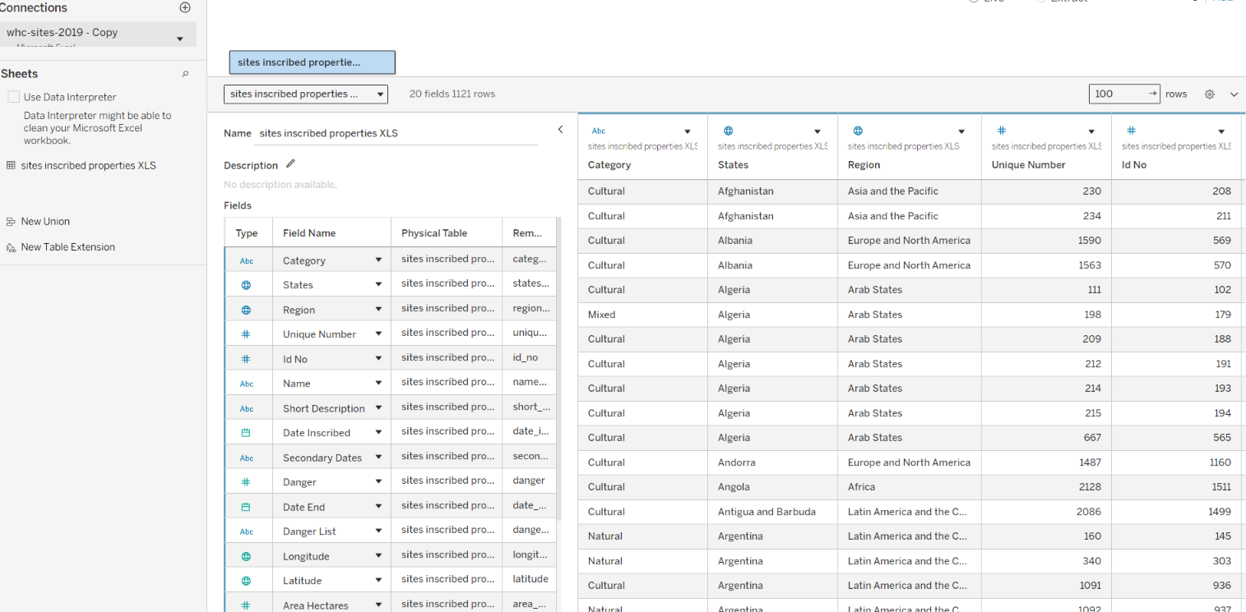
Figure 2: Cleaned Data


Figure-3: Used Filters
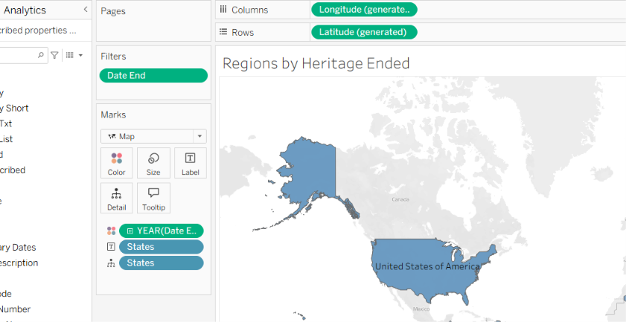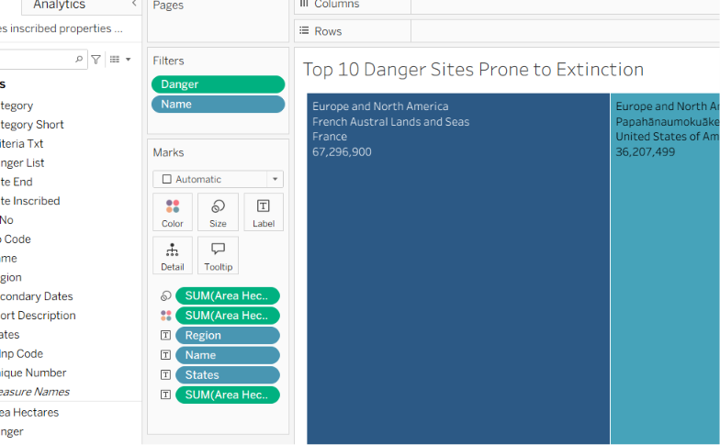

Figure-4: Dashboard
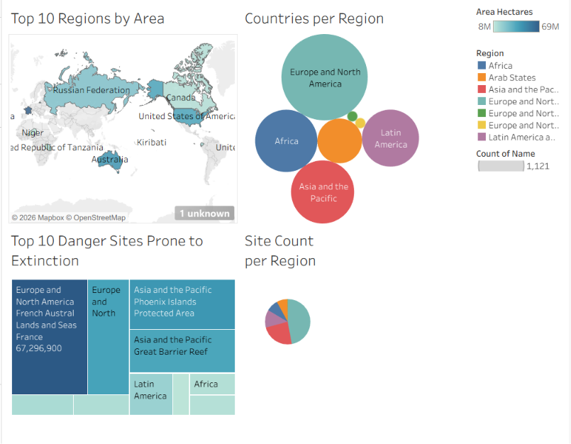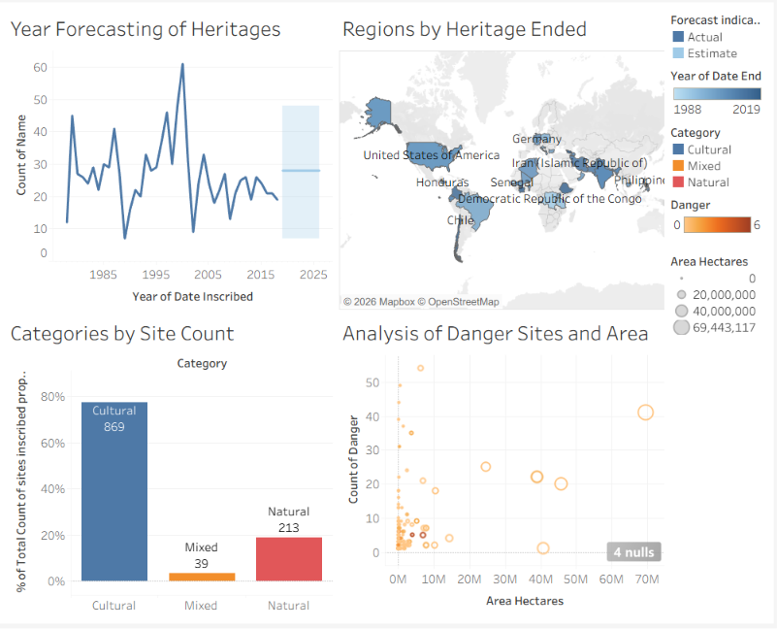

Figure-5: Story
